**Time- 3 H SCIENCE-IX M.M-90**

**General Instructions:**

(i)The question paper comprises of two sections ,A and B .You are to attempt both the sections.

(ii)All questions are compulsory.

(iii)There is no overall choice.

(iv)All questions of section A and all questions of section B are to be attempted separately.

(v)Question numbers 1 to 3 in section A are one mark questions .These are to be answered in

one word or in one sentence.

(vi)Question numbers 4 to 6 in section A are two marks questions.These are to be answered in

about 30 words each.

(vii)Question numbers 7 to 18 in section are three marks questions .These are to be answered in

about 50 words each.

(viii)Question numbers 19 to 24 in section A are five marks question.These are to be answered in

about 70 words each.

(ix)Section B are multiple choice questions based on practical skills.Question numbers 25 to 33 are

one mark questions .Question numbers 34 to 36 are two marks question .You are to select one

most appropriate response out the four provided to you

**1.** Give any two applications of Archimedes’’ principle.

**2.** What are the abiotic components of biosphere?

**3.** Give one use of lichens.

**4.** (a)Swimmers are provided with an inflated rubber jacket .Why?

(b)It is easier to swim in sea water than in river water .Justify.

**5.** Write the distribution of electrons in carbon and sodium atoms.

**6.** Why are anti viral medicines difficult to manufacture as compared to anti bacterial medicines?

**7.** (a)In a game of tug of war, one team is slowly giving way to the other .Which team is doing positive

work and which team negative?

(b)Define kinetic energy of an object. On which factors does it depend ?Can kinetic energy of an

object be negative?

**8.** Define thrust and pressure.

The volume of a 500 g sealed packet is 350 cm3 .Will the packet float or sink in water if the density of

water is 1 g cm-3 ?What will be the weight of water displaced by the packet?

**9.** (a)A person holds a bundle of hay over his head for 30 minutes and gets tired. How he done some

work? Justify your answer.

(b)A man of mass 60 kg runs up a flight of 30 steps in 40 s.If each step is 20 cm high. Calculate his

power.

**10.** Describe, with the help of a diagram, how compressions and rarefactions’ are produced in air near a

source of sound.

A person is listening to a tone of 500Hz sitting at a distance of 450 m form the source of sound

.What is the time interval between successive compressions from the source?

**11.**Smita studies in class VIII in Govt .Sr.Secondary School,Bharat Nagar ,Delhi. During summer vacations

the school arranged an educational trip to Agra.Smita too joined the tour party .During their visit to

Taj Mahal ,when Smita and other students entered the mausoleum of Mumtaj Mahal and King

Shahjahan ,she heard a mild persistent sound these .Their guide told them that soul of Mumtaj

Mahal is still wandering here and that is the cause of persistent sound .Smita did not belive him. She

asked her science teacher Jyoti,who told her that it is the phenomenon of reverberation of sound

.Reverberation as well as echo phemenon are due to reflection of sound .Now Smita knew the real

cause of presence of persistent sound inside the mausoleum.

(i)How can you define reverberation of sound?

(ii)What is the difference between reverberation and echo phenomena?

(iii)What qualities were exhibited by Smita?

**12.** Calculate the molecular masses of the following compounds:

(a)Acetic acid (CH3COOH) (b)Ethanol (C2H5OH) (c) Carbon dioxide

**13.**A and B are two atoms in whole nuclei ,the number of protons and neutrons are :

Atoms Protons Neutrons

A 6 6

B 6 7

Which element/elements do they represent and what is the relation between them?

**14.** Out of Na +,K+, Al 3+, O2- and F- ,which are isoelectronic?

**15.** What are the various methods to control pollution?

**16.** What do you know about the hole in the ozone layer? Explain the probable damages caused by it?

**17.** Differentiate between bryophytes and pteridophytes.

**18.** Explain how HIV-AIDS virus affects and damages our body?

**19.**(a)Water stored in a huge dam built in a hilly terrain is used to produce electric power Explain,

various types of energy transformations taking place in the process.

(b)Define the commercial unit of energy .What is its value in joules?

(c)A car weighing 1200 kg is uniformly accelerated from rest and covers a distance of 40 m in 5

s.Calculate the work done by the engine of the car during this time.

**20.** (a)What is sound and how is it produced?

(b)Describe an activity to show reelection of sound waves.

(c)A stone is dropped from the top of a high rise tower 500 m high into a pond of water at the base

of the tower .When is the splash hearted at the top ?Given that g=10 m-2 and speed of sound of

sound in air =333.3 m s-1.

**21.** Using the valencies, write down the chemical formulae of the following compounds:

(i)Calcium nitrate (ii) Lead acetate (iii) Barium chloride (iv) Silica

(v)Phosphine (vi) Baking soda (vii) Caustic soda (viii) Carbon tetrachloride

(ix)Potassium chlorate (x) Ammonium sulphate

**22.** (a)What causes winds? (b)How are causes formed?

**23.** What is the hierarchy of categories? Depict it in the form of flow chart .Describe the characteristics

used for hierarchical classification.

**24.** (a)Why whales are not grouped under Pisces using a spring balance and a measuring cylinder,Seema

carried out the following procedure

(i)noted the water level in the measuring cylinder without the copper piece.

(ii)immersed the copper piece in the water.

(iii)noted the water level in measuring cylinder with the copper piece inside it.

(iv)removed the copper piece from the water and immediately weighed it using a spring balance.

The wrong step in the procedure is:

(a)step (i) (b)step(ii) (c)step(iii) (d)step(iv)

**26.** In the experiment of finding volume of a solid by immersing it into water, the initial reading of water

level in graduated cylinder was 16.2 mL.On immersing the given solid completely into water ,the

water level in graduated cylinder rose to 19.7 mL.

(a)16.2 mL (b)19.7 mL (c)3.5 mL (d)

**27.** (a) An iron cuboid of length I=10 cm, bredth from the base.

(b) maximum when breadth and thickness from the base.

(c) maximum when length and thickness form the base.

(d)minimum when breadth and thickness form the base.

**28.** A student observed the following precautions in an experiment on law of conservation of mass

carried out in a closed vessel.

(a)Ensure that the pointer of the balance is at zero before making use of it.

(b)Ensure that the reaction mixture comes to room temperature before taking the weight

(c)The balance must be slightly tilted towards the left.

(d)Ensure that the constituents of the mixture come into contact completely. Which of the

precautions taken were unnecessary ?

**29.**Four students did their experiment on measuring the speed of a pulse through a string as follows:

Student A stretched his thick cotton string very taut and give it a very mild transverse horizontal jerk

Student B stretched his thin jute taut and give it a mild transverse horizontal jerk.

Student C stretched his thick cotton string just taut and gave it a strong transverse horizontal jerk.

Student D stretched his thin jute string very taut and gave it a strong transverse horizontal jerk.

The best choice is that of student

(a)A (b)B (c)C (d)D

**30.** The forelimbs of birds are modified as:

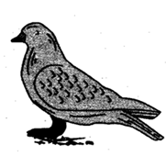

(a)Legs (b)Scales (C)Wings (d)Clawed toes

**31.** A specimen of fish was given to the students to identify the externally visible chordate feature in it

.The student would look for

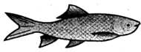

(a)Operculum (b)Notochord (c)Dorsal tubular nerve cord (d)Post anal tail

**32.**Identify the name of part A depicted in the picture given below.

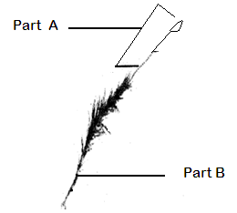

(a)Sporophyte (b)Gametophyte (c)Capsule (d)Rhizoids

**33.** How many stages of lifecycle of mosquito pass in water?

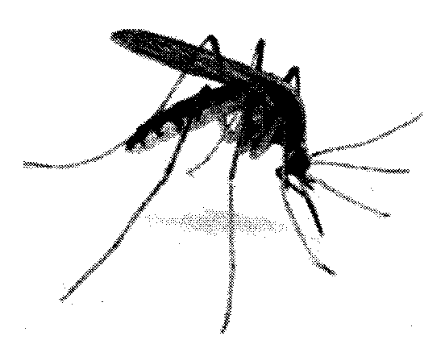

(a)4 (b)3 (c)2 (d)1

**34.** The characteristic features of monocot angiosperms are:

I. Presence of fibrous root system. II.They are herbs.

III.The leaves are sessile with reticulate venation. IV.Flowers are timerous.

Which of the following group is correct?

(a)I,II,III (b)I,II,IV (c)II,III,IV (d)I,III,IV

**35.** You are given solid cubes of aluminium and iron ,each of side 4 cm ,and two spring balances .Balance

has a range count of 10 g .The preferred option for mass measurement would be to use:

(a)balance A for both the cubes. b)balance B for both the cubes.

(c)balance A for aluminium cube and balance B for iron cube.

(d)balance A for iron cube and balance B for iron cube.

**36.** A strong transverse horizontal pulse ,created at one of a string is observed to complete 5 journeys

along its length ,before fading out .The initial and final readings ,on a stop clock used in the

experiment ,are as shown here .If the length of the string is L metre .,the speed of the pulse through

the string is :

(a) (b)  (c)  (d) 

